**Jonathan Weaver**

**Robotics Team Competition Test Cases**

| **Input** | **Expected Output** | **Actual** **Output** | **Pass?** |
| --- | --- | --- | --- |
| How many teams do you want to enter: 2  Team 1:  Enter team's name: Xtreme United  Enter team's score (400-1000): 450  Team 2:  Enter team's name: American Bull  Enter team's score (400-1000): 670 | Xtreme United 450  American Bull 670  The American Bull have the highest score => 670 and The Xtreme United have the lowest score => 450 | Xtreme United 450  American Bull 670  The American Bull have the highest score => 670 and The Xtreme United have the lowest score => 450 | YES |
| How many teams do you want to enter: 3  Team 1:  Enter team's name: Lightning Zappers  Enter team's score (400-1000): 890  Team 2:  Enter team's name: Commando Squad  Enter team's score (400-1000): 678  Team 3:  Enter team's name: Red Legends  Enter team's score (400-1000): 522 | Lightning Zappers 890  Commando Squad 678  Red Legends 522  The Lightning Zappers have the highest score => 890 and The Red Legends have the lowest score => 522 | Lightning Zappers 890  Commando Squad 678  Red Legends 522  The Lightning Zappers have the highest score => 890 and The Red Legends have the lowest score => 522 | YES |
| How many teams do you want to enter: 1  Team 1:  Enter team's name: Awesome Hurricanes  Enter team's score (400-1000): 200 | Team's score should be between 400 and 1000 | Team's score should be between 400 and 1000 | YES |
| How many teams do you want to enter: 4  Team 1:  Enter team's name: The Untouchables  Enter team's score (400-1000): 400  Team 2:  Enter team's name: Animal Crackers  Enter team's score (400-1000): 540  Team 3:  Enter team's name: Walkie Talkies  Enter team's score (400-1000): 780  Team 4:  Enter team's name: The Herd  Enter team's score (400-1000): 999 | The Untouchables 400  Animal Crackers 540  Walkie Talkies 780  The Herd 999  The The Herd have the highest score => 999 and The The Untouchables have the lowest score => 400 | The Untouchables 400  Animal Crackers 540  Walkie Talkies 780  The Herd 999  The The Herd have the highest score => 999 and The The Untouchables have the lowest score => 400 | YES |

**Screen Capture**

**Test Case 1:**

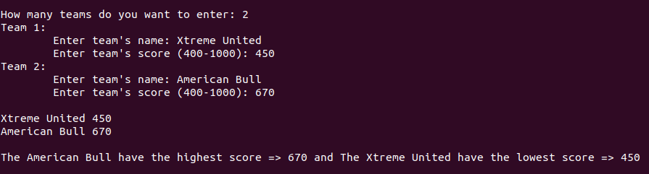

**Test Case 2:**

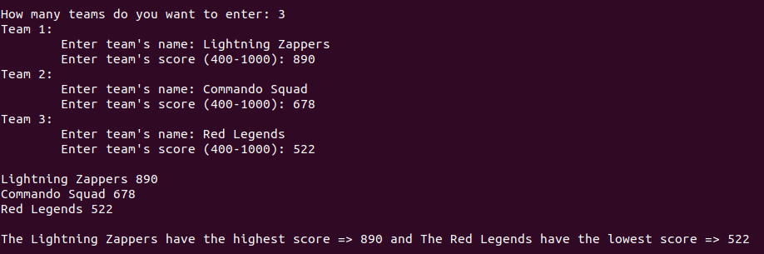

**Test Case 3:**



**Test Case 4:**

